COMPUTER GRAPHICS

&

IMAGE PROCESSING

LAB MANUAL 6

PREPARED BY:: ENGR. ALI JAVED

IMAGE FILTERING IN FREQUENCY DOMAIN

LAB OBJECTIVE:

The objective of this lab is to understand & implement

- Image enhancement in frequency domain.

- Low Pass Filters

- Gaussian low pass filter
- Butterworth low pass filter
- Ideal low pass filter

- High Pass Filters

- Gaussian high pass filter
- Butterworth high pass filter
- Ideal high pass filter

BACKGROUND MATERIAL:

Discrete Fourier Transform

What is the Discrete Fourier Transform?
The general idea is that the image (f(x,y) of size M x N) will be represented in the frequency domain (F(u,v)). The equation for the two-dimensional discrete Fourier transform (DFT) is:
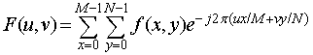
The concept behind the Fourier transform is that any waveform that can be constructed using a sum of sine and cosine waves of different frequencies. The exponential in the above formula can be expanded into sines and cosines with the variables u and v determining these frequencies.
The inverse of the above discrete Fourier transform is given by the following equation:
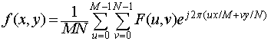
Thus, if we have F(u,v), we can obtain the corresponding image (f(x,y)) using the inverse, discrete Fourier transform.
Things to note about the discrete Fourier transform are the following:
- the value of the transform at the origin of the frequency domain, at F(0,0), is called the dc component
  - F(0,0) is equal to MN times the average value of f(x,y)
  - in MATLAB, F(0,0) is actually F(1,1) because array indices in MATLAB start at 1 rather than 0
- the values of the Fourier transform are complex, meaning they have real and imaginary parts. The imaginary parts are represented by i, which is the square root of -1
- we visually analyze a Fourier transform by computing a Fourier spectrum (the magnitude of F(u,v)) and display it as an image.
  - the Fourier spectrum is symmetric about the origin
- the fast Fourier transform (FFT) is a fast algorithm for computing the discrete Fourier transform.
- MATLAB has three functions to compute the DFT:
  - fft -for one dimension (useful for audio)
  - fft2 -for two dimensions (useful for images)
  - fftn -for n dimensions
- MATLAB has three functions that compute the inverse DFT:
  - ifft
  - ifft2
  - ifftn

How does the Discrete Fourier Transform relate to Spatial Domain Filtering?
The following convolution theorem shows an interesting relationship between the spatial domain and frequency domain:
and, conversely,
the symbol "*" indicates convolution of the two functions. The important thing to extract out of this is that the multiplication of two Fourier transforms corresponds to the convolution of the associated functions in the spatial domain.

Basic Steps in DFT Filtering
The following summarize the basic steps in DFT Filtering
- Obtain the padding parameters using function paddedsize:
PQ=paddedsize(size(f));
- Obtain the Fourier transform with padding:
F=fft2(f, PQ(1), PQ(2));
- Generate a filter function, H, of size PQ(1) x PQ(2)....
- Multiply the transform by the filter:
G=H.*F;
- Obtain the real part of the inverse FFT of G:
g=real(ifft2(G));
- Crop the top, left rectangle to the original size:
g=g(1:size(f, 1), 1:size(f, 2));

Lowpass and Highpass Frequency Domain Filters
Based on the property that multiplying the FFT of two functions from the spatial domain produces the convolution of those functions, you can use Fourier transforms as a fast convolution on large images. As a note, on small images, it is faster to work in the spatial domain.
However, you can also create filters directly in the frequency domain. There are two commonly discussed filters in the frequency domain:
- Lowpass filters, sometimes known as smoothing filters
- Highpass filters, sometimes known as sharpening filters

Lowpass Frequency Domain Filters
Lowpass filters:
- create a blurred (or smoothed) image
- attenuate the high frequencies and leave the low frequencies of the Fourier transform relatively unchanged
Three main lowpass filters are discussed in Digital Image Processing Using MATLAB:
- ideal lowpass filter (ILPF)
- Butterworth lowpass filter (BLPF)
- Gaussian lowpass filter (GLPF)
The corresponding formulas and visual representations of these filters are shown in the table below. In the formulae, D₀ is a specified nonnegative number. D(u,v) is the distance from point (u,v) to the center of the filter.

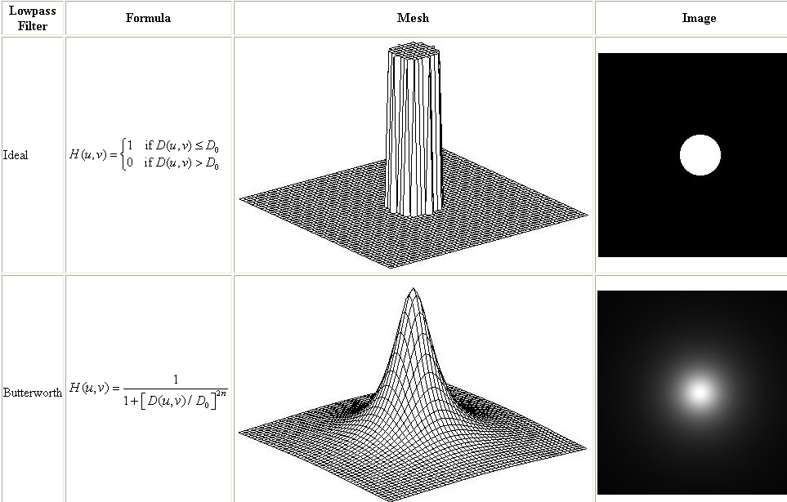
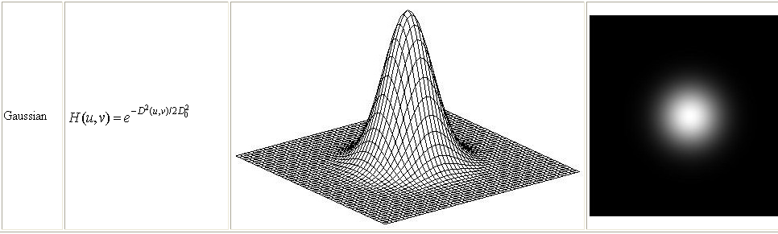

Highpass Frequency Domain Filters
Highpass filters:
- sharpen (or shows the edges of) an image
- attenuate the low frequencies and leave the high frequencies of the Fourier transform relatively unchanged
The highpass filter (H_{hp} ) is often represented by its relationship to the lowpass filter (H_{lp}):
Because highpass filters can be created in relationship to lowpass filters, the following table shows the three corresponding highpass filters by their visual representations:
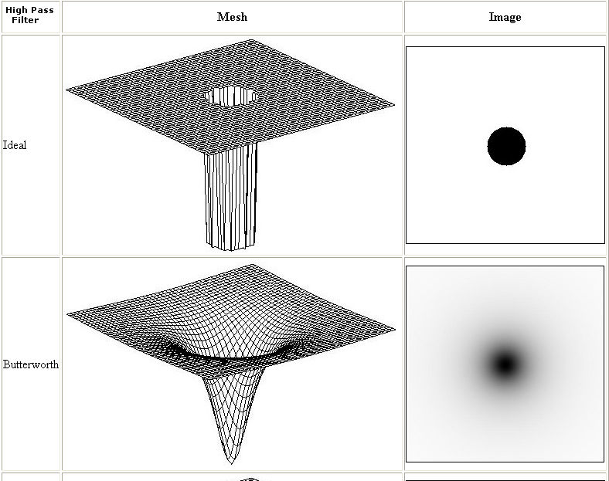
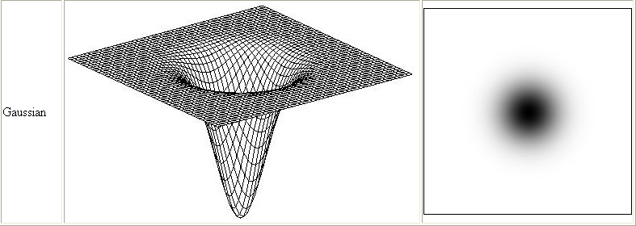

IMPLEMENTATION DETAILS WITH RESULTS:

Gaussian Low Pass Filter
MATLAB CODE
image=imread('cameraman.tif');
imshow(image);
[m,n]=size(image);
image=im2double(image);
F=fft2(image);
F=fftshift(F);
Sigma=10;
H=fspecial('gaussian',[m n],sigma);
G=H.*F;
G=ifftshift(G);
g=real(ifft2(G));
figure,imshow(g,[])
OUTPUT
Sigma/Distance=10;

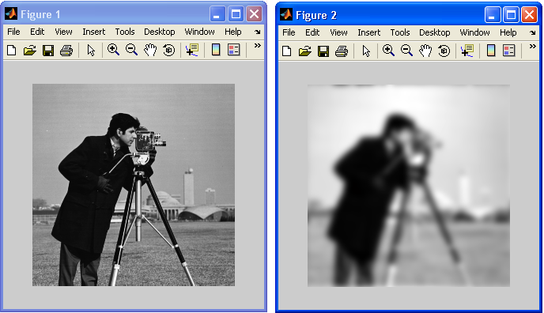

ORIGINAL IMAGE IMAGE AFTER Gaussian LPF

OUTPUT
Sigma/Distance=30;
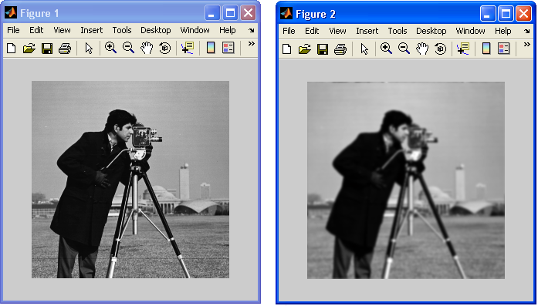
ORIGINAL IMAGE IMAGE AFTER Gaussian LPF

Gaussian Low Pass Filter
MATLAB CODE (using function lpfilter)
image=imread('cameraman.tif');
imshow(image);
[m,n]=size(image);
image=im2double(image);
F=fft2(image);
F=fftshift(F);
sigma=10;
H=lpfilter('gaussian',m, n,sigma);
G=H.*F;
G=ifftshift(G);
g=real(ifft2(G))
figure,imshow(g,[])

Gaussian High Pass Filter
MATLAB CODE (using function hpfilter)
image=imread('cameraman.tif');
imshow(image);
[m,n]=size(image);
image=im2double(image);
F=fft2(image);
F=fftshift(F);
sigma=10;
H=hpfilter('gaussian',m, n,sigma);
G=H.*F;
G=ifftshift(G);
g=real(ifft2(G))
figure,imshow(g,[])

Butterworth Low Pass Filter
MATLAB CODE (using function lpfilter)
image=imread('cameraman.tif');
imshow(image);
[m,n]=size(image);
image=im2double(image);
F=fft2(image);
F=fftshift(F);
Order=2;
H=lpfilter('btw',m ,n ,order);
G=H.*F;
G=ifftshift(G);
g=real(ifft2(G))
figure,imshow(g,[])

Butterworth High Pass Filter
MATLAB CODE (using function hpfilter)
image=imread('cameraman.tif');
imshow(image);
[m,n]=size(image);
image=im2double(image);
F=fft2(image);
F=fftshift(F);
Order=2;
H=hpfilter('btw',m ,n ,order);
G=H.*F;
G=ifftshift(G);
g=real(ifft2(G))
figure,imshow(g,[])

Ideal Low Pass Filter
MATLAB CODE (using function lpfilter)
image=imread('cameraman.tif');
imshow(image);
[m,n]=size(image);
image=im2double(image);
F=fft2(image);
F=fftshift(F);
H=lpfilter('ideal',m ,n ,Do); % Do =cutoff distance
G=H.*F;
G=ifftshift(G);
g=real(ifft2(G))
figure,imshow(g,[])

Ideal High Pass Filter
MATLAB CODE (using function hpfilter)
image=imread('cameraman.tif');
imshow(image);
[m,n]=size(image);
image=im2double(image);
F=fft2(image);
F=fftshift(F);
H=hpfilter('ideal',m ,n ,Do); % Do =cutoff distance
G=H.*F;
G=ifftshift(G);
g=real(ifft2(G))
figure,imshow(g,[])

******************************************************************

TASK 1
Implement Gaussian High pass filter without the function hpfilter().But you can use fspecial() function

******************************************************************

******************************************************************

TASK 3
Identify which of the following is the result of a lowpass or highpass Butterworth filter.
Image 1 | Image 2
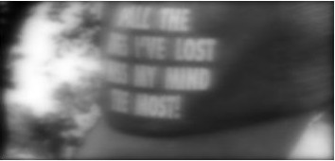 | 




