University of Engineering & Technology, Taxila
Department of Electrical Engineering
MSc / PhD TIMETABLE
Semester Spring-2021 (w.e.f: 26-04-2021)

Time/Day | Monday | Tuesday | Wednesday |  | Thursday | Friday
3:00 P.M.  To  6:00 P.M | EE-5120  Special Topics in Power | EE-5204  VLSI Design |  |  | EE-5201  Semiconductor Materials and Technology | EE-5001  Research Methodology | EE-6003  Research Methodology
 |  | EE-5102  Electrical Machine Modeling | EE-5104  Renewable Energy Systems |  | EE-5314  Machine Learning
 |  |  |  |  | EE-5403  Linear Multivariable Control | EE-5315  Special Topics in Digital Techniques | EE-6304  Digital Image and Video Processing
6:00 P.M.  To  9:00 P.M | EE-5105  Power System Operation |  | EE-5301 Digital Signal Processing | EE-6303  Advanced Digital Speech Processing | EE-5209  VLSI Testing and Verification
EE-5404
Optimal Control

S. No. | Course Code | Entry | Course Name | Teacher Name | Specialization | Type | Classroom No.
 | EE-5102 | 2018 Onwards | Electrical Machine Modeling | Engr. Dr. Munira Batool | Power | CORE
 | EE-5104 | 2018 Onwards | Renewable Energy Systems | Prof. Dr. Salman Amin | Power | CORE
 | EE-5105 | 2018 Onwards | Power System Operation | Dr. Faisal Nadeem | Power | Elective
 | EE-5001 / EE-6003 | 2018 Onwards | Research Methodology | Prof. Dr. Aftab Ahmad | Compulsory for all MSc Students | Elective for all PhD students
 | EE-5201 | 2018 Onwards | Semiconductor Materials and Technology | Prof. Dr. Shabbir Majeed | Electronics | CORE
 | EE-5204 | 2018 Onwards | VLSI Design | Engr. Dr. Waqar Ahmad  (Computer Engg. Deptt.) | Electronics | CORE
 | EE-5209 | 2018 Onwards | VLSI Testing and Verification | Prof. Dr. Iram Baig | Electronics | Elective
 | EE-5301 | 2018 Onwards | Digital Signal Processing | Prof. Dr. M. Obaid Ullah | Digital Techniques | CORE
 | EE-6303 | 2018 Onwards | Advanced Digital Speech Processing |  | Digital Techniques | Elective (PhD)
 | EE-5314 | 2018 Onwards | Machine Learning | Dr. Syed M. Anwar  (Software Engg. Deptt.) | Digital Techniques | Elective
 | EE-5315 | 2018 Onwards | Special Topics in DT | Prof. Dr. Gulistan Raja | Digital Techniques | Elective
 | EE-6304 | 2018 Onwards | Digital Image and Video Processing |  | Digital Techniques | Elective (PhD)
 | EE-5403 | 2018 Onwards | Linear Multivariable Control | Engr. Dr. Inam Ul Hassan Shaikh | Control | CORE
 | EE-5404 | 2018 Onwards | Optimal Control | Engr. Dr. Ahsan Ali | Control | CORE

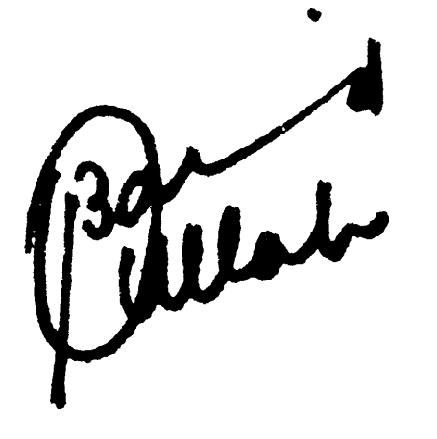
(Prof. Dr. Muhammad Obaid Ullah)
Director PGS, EED
(Prof. Dr. Aftab Ahmad)
Chairman EED

Copy to:

- The Dean, Faculty of Electronics and Electrical Engineering.
- The Director, (ASR & TD), UET, Taxila.
- The Chairman CPED
- All Concerned Faculty Members.
- The Secretary to Vice-Chancellor.
- Concerned File.

Notes for Students:
- MSc course codes start with digit 5.
- PhD course codes start with digit 6.
- An MS course is offered if at least 05 students are registered in that course.
- Apart from the Specialization Core Courses, the course of Research Methodology is a compulsory course for all the specializations and treated as a pre-requisite for Research Thesis.
- With prior permission from Chairman EED, an MS student can take / opt the elective course(s) from other than his/her Specialization Elective Courses.
- If a PhD student wants to take the elective course(s) other than his/her Specialization Elective Courses, a permission from the Chairman will be required to opt that/those course(s).
- With prior permission from Chairman EED, an MS student can take / opt PhD course(s) as an elective.
- All applications to the chairman EED must be routed through advisor of concerned specialization.
- Instead of using course codes mentioned in this time table, students from entries 2017 or before are required to use course codes as per their prospectus.

Email IDs of Teacher teaching courses in S-21 Semester
Teacher Name | Specialization
Engr. Dr. Munira Batool | munira.batool@uettaxila.edu.pk
Prof. Dr. Salman Amin | salman.amin@uettaxila.edu.pk
Dr. Faisal Nadeem | faisal.nadeem@uettaxila.edu.pk
Prof. Dr. Aftab Ahmad | aftab.ahmad@uettaxila.edu.pk
Prof. Dr. Shabbir Majeed | shabbir.majeed@uettaxila.edu.pk
Engr. Dr. Waqar Ahmad  (Computer Engg. Deptt.) | waqar.ahmad@uettaxila.edu.pk
Prof. Dr. Iram Baig | iram.baig@uettaxila.edu.pk
Prof. Dr. M. Obaid Ullah | obaid.ullah@uettaxila.edu.pk
Prof. Dr. M. Obaid Ullah
Dr. Syed M. Anwar  (Software Engg. Deptt.) | s.anwar@uettaxila.edu.pk
Prof. Dr. Gulistan Raja | gulistan.raja@uettaxila.edu.pk
Prof. Dr. Gulistan Raja
Engr. Dr. Inam Ul Hassan Shaikh | inam.hassan@uettaxila.edu.pk
Engr. Dr. Ahsan Ali | ahsan.ali@uettaxila.edu.pk

