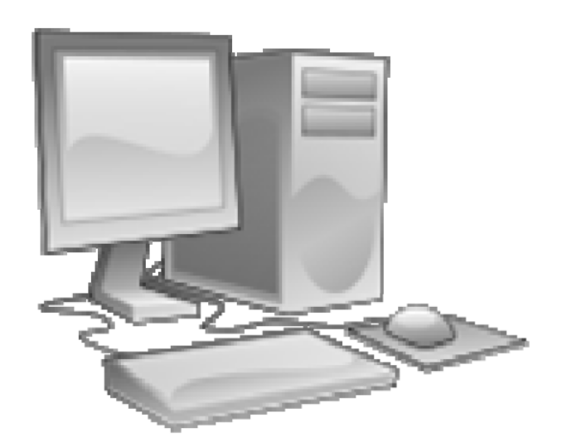

INTRODUCTION TO COMPUTING

(LAB WORK MANUAL)

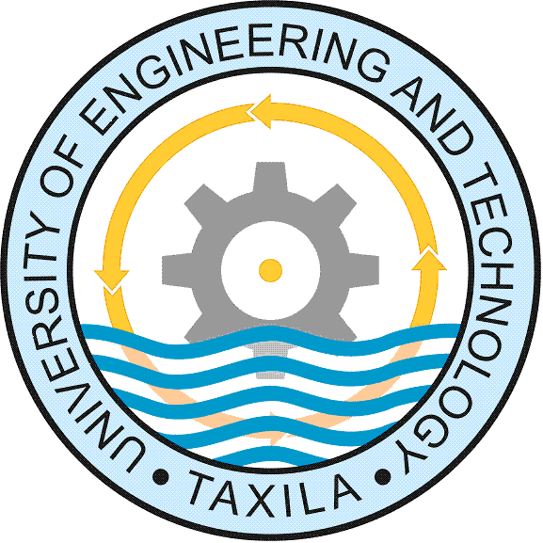

University of Engineering & Technology, Taxila

COMPUTER SYSTEMS AND
BASIC COMPUTER
HARDWARE ORGANIZATION

LAB MANUAL 1

OBJECTIVE:

Computer systems will be explained and the basic hardware elements of a personal computer system (PC) will be described. The nature and purpose of each of the hardware elements will be identified.

EXPLANATIONS:
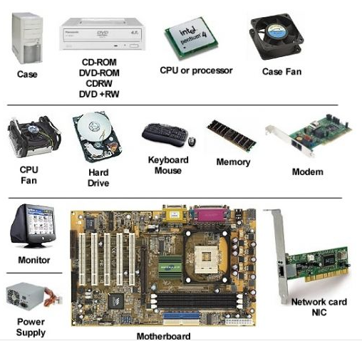

A COMPUTER SYSTEM

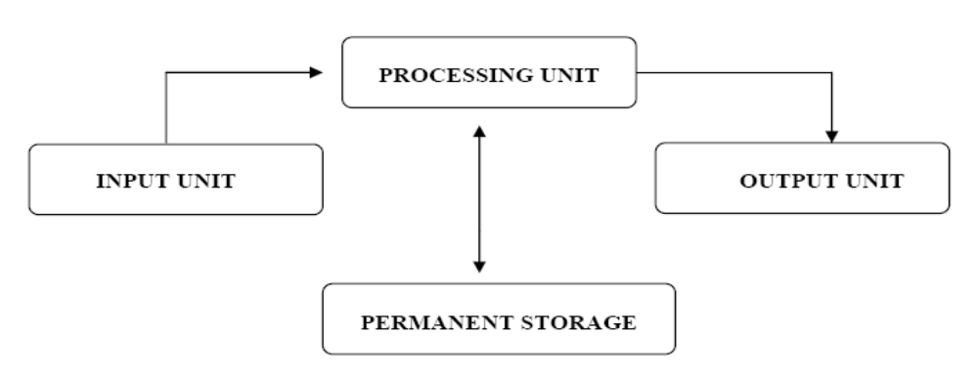
All computer systems, no matter how small or large, have the same fundamental capabilities: processing, storage, input and output.

INPUT UNIT:
Input unit includes devices like keyboard and mouse, which are used by the user
to give some data to the computer.

PROCESSING UNIT:
Processing unit is where these data are processed and turned into meaningful information. Processing
unit also includes temporary storage (RAM) in which the data currently being processed are stored temporarily.

OUTPUT UNIT:
To show the result of processes, to the user, output devices like monitors and printers are used. The output on a monitor is usually called softcopy and the output on a printer is usually called hardcopy.

PERMANENT STORAGE:
Sometimes we may want to store our data and information permanently so that we can refer to them again, later. For this purpose, interchangeable devices like floppy disk drives and CD-ROM drives, or permanently installed devices like hard disks are used as permanent storage medium.

AN INTERNAL LOOK TO A PC

The following are the hardware components that exist almost in all PCs.

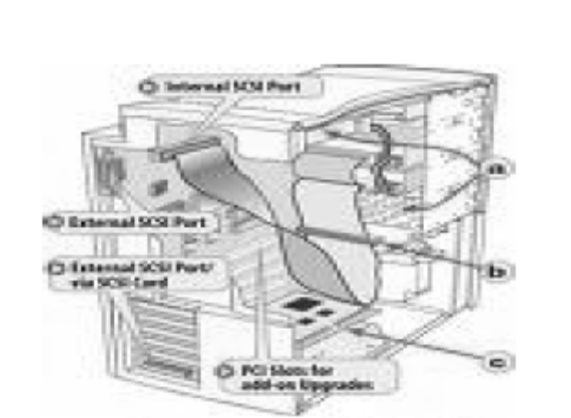

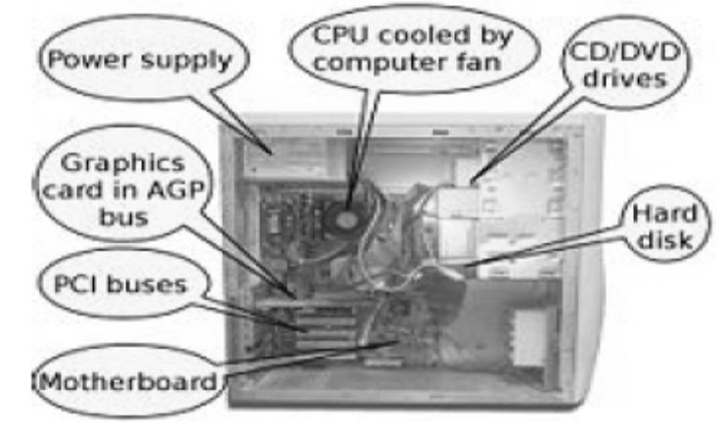

MOTHERBOARD:

It is a microcomputer circuit board that contains slots for connecting peripherals like RAM modules, CPU and adapter cards. Motherboards also have electronic circuitry for handling such tasks as I/O signals from those peripheral devices. A motherboard is the backbone of a computer system: The power of a PC highly depends on the peripherals that its motherboard supports.

CPU:

It is the brain of a computer system. It is the component, which controls what’s going on in the system at any moment. Other components act according to the orders of the CPU. All the current inputs and any previously stored data are processed by the CPU to obtain meaningful information.

RAM:

It is the primary memory of a PC. Anything in a secondary storage device (permanent storage) that has to be processed by the CPU, must first be loaded to RAM, because there are no machine instructions to directly access and use any data which is stored in a secondary storage medium. RAM is a volatile memory, therefore if electricity cut or a reset should occur; all the data in RAM are lost.

HARD DISK:

It is one of the most popular secondary storage devices. It is a magnetic medium that stores its contents permanently, even in the absence of electricity power. You store your documents, pictures, photos, songs, etc in Hard disks.

FLOPPY DISK DRIVE:

It is a device into which you insert interchangeable floppy disks. Floppy disks are also magnetic storage mediums. FDDs works much slower than Hard disks and floppy disks have much smaller storage capacities. Floppy disks are usually used to copy some files from your PC to another PC, vice versa.
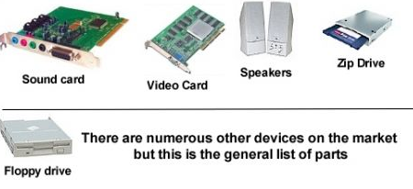

GRAPHICS CARD:

This circuit board is responsible from the visual outputs that will be displayed on the monitor. Nowadays, graphics cards have their own memory modules and processor chips, by which they lessen the load of CPU and RAM, hence enabling us to see very detailed graphics and high quality animations and video.
PCs are general-purpose devices that can be used in many areas of interest, and of course there exists many other hardware components that can be added to them to increase their functionalities. These include CD-ROM drives, sound cards, radio cards, TV cards, modem cards, etc…


