Guidelines for recording videos on zoom

Accessing Zoom
- If you have not already used Zoom, please register with Zoom (for free) by going to https://zoom.us/
Click Sign Up, It’s Free and follow the on-screen instructions.
- You can download the Zoom app, if you have not already done so, by going to https://zoom.us/download. Click Download and follow the on screen or device prompted instructions.
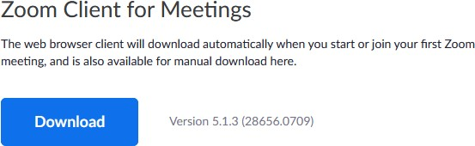

Recording your presentation
- Launch the Zoom app.
- Click the New Meeting icon.
- Click Join with Computer Audio (and/or Video) if prompted to do so.

You may wish to test your audio by clicking Test Speaker and Microphone by following the on-screen instructions.
- A window will appear with your image projected from your web cam. You will be able to see a toolbar at the bottom of the web cam window by hovering your mouse cursor over the web cam window. Ensure that your audio is working by speaking into it and noting that the microphone icon turns green.
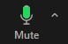

- Ensure that your prepared presentation is open in a separate window (e.g. PowerPoint). On the same toolbar, click the Share Screen icon (a).
- Select the window that displays your presentation (b).
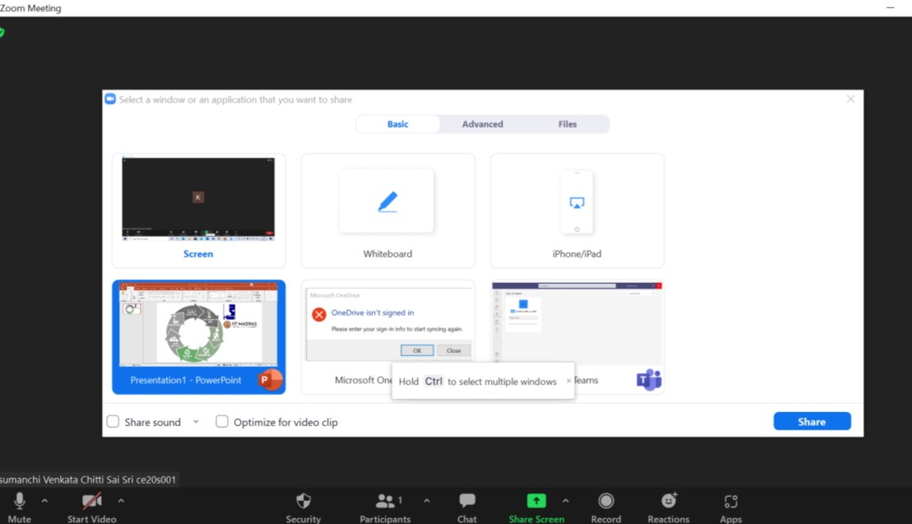
(
b
)

Click Share. Your presentation will appear and your web cam window should appear as a small box to the right hand side of your screen.
- Click the Slide Show icon to show the presentation in full screen mode.

- Hover your mouse cursor over the top of the green bar at the top of the screen displaying “You are screen sharing”.
A menu will appear - hover your mouse cursor over the More icon.
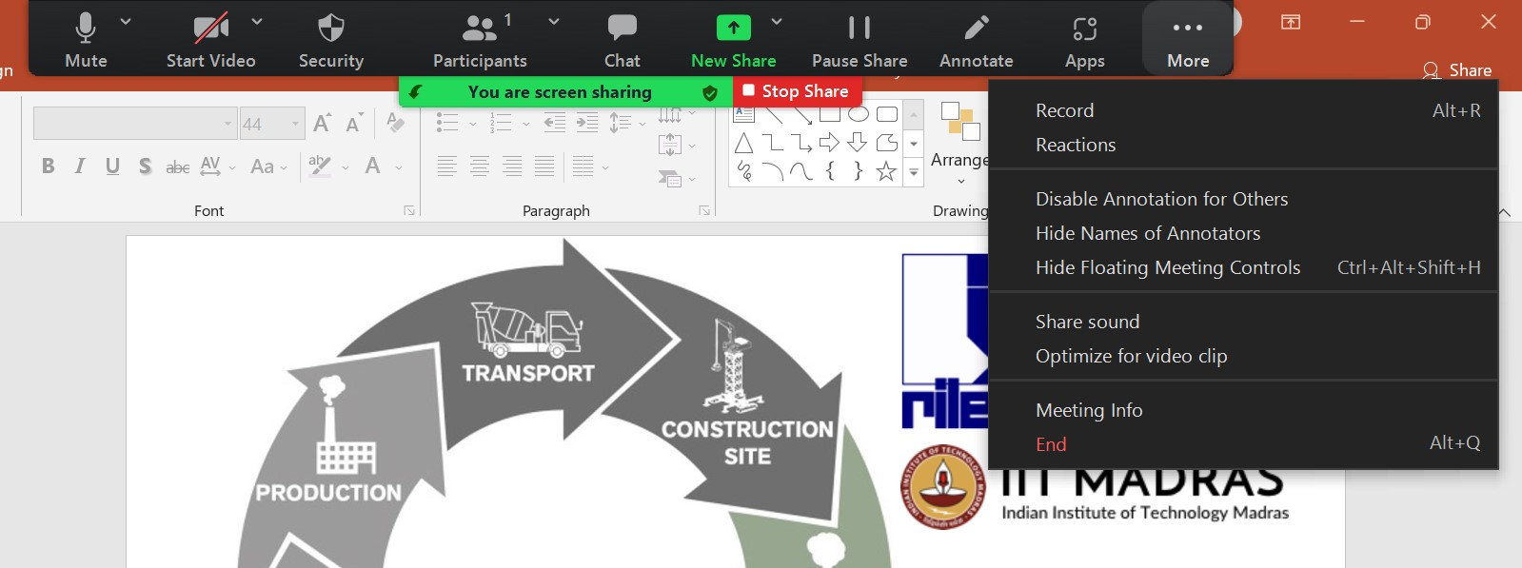
(
C
)
)

(
d
)

(
e
)

Select and click Record (c) - a red dot will appear in the green bar area (d) that indicates that Zoom is recording.
You should now record your presentation.

- To finish recording, select and click Stop Recording from the same menu (c).
- Stop screen sharing by clicking Stop Share (e).

- To leave the session, click End on the main web cam window, followed by End Meeting for All.
- Zoom will automatically convert your recording into several files - please be patient as this may take a while.
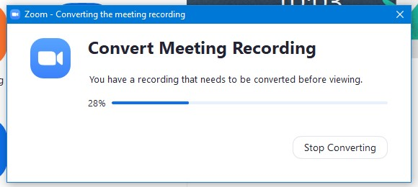

- Zoom will create a folder in your Documents folder, named Zoom, where it will save the files - this should automatically open once Zoom has finished converting the files.

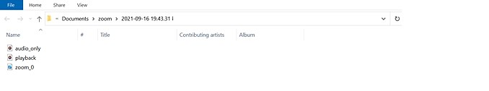
- The required file will be named zoom_0.
- Rename the file as (Firstname_Lastname)

