Full Paper Title in Title Case

Name Surname¹, Name Surname²
¹Organization/Institution/Company, email address
²Organization/Institution/Company, email address

In this paper, the formatting requirements for the 3rd International Conference on Advances in Civil & Environmental Engineering (ICACEE-2024), UET TAXILA are described. Some recommendations on writing for a worldwide readership are offered. Please review this document to learn about the formatting of text, table captions, references, and the method to include the indexing information. The conference proceedings will be published in an electronic format. The full paper in MS Word file shall be written in compliance with these instructions. At a later stage, it will be converted into Portable Document Format (PDF).

ABSTRACT
An abstract not exceeding 250 words should appear on the top of the first page, after the title of the paper in a section titled "ABSTRACT" (without section number), after the names of the authors.

KEYWORDS: 3-5 keywords

INTRODUCTION
It is expected that authors will submit carefully written and proofread material. Careful checking for spelling and grammatical errors should be performed. The number of pages of the paper should be from 4 to 6.
Papers should clearly describe the background of the subject, the authors work, including the methods used, results and concluding discussion on the importance of the work. Papers are to be prepared in English and SI units must be used. Technical terms should be explained unless they may be considered to be known to the conference community.

paper format
The uniform appearance will assist the reader to read paper of the proceedings. It is therefore suggested to authors to use the example of this file to construct their papers. This particular example uses an American letter format with 25 mm margins left, right, top and bottom.
All text paragraphs should be single spaced, with first line intended by 10 mm. Double spacing should only be used before and after headings and subheadings as shown in this example. Position and style of headings and subheadings should follow this example. No spaces should be placed between paragraphs.

Header, Footer, Page Numbering
Authors are asked to replace the "XXX" number (with the paper code that will assigned when the paper will be accepted) on the header of the first page and on the footer of other pages in order to set a unique page number in the Proceedings.

Fonts
Papers should use 12-point Times New Roman font.

Tables and Figures
Figure and table captions should be sufficient to explain the figure or table without needing to refer to the text. Figures and tables not cited in the text should not be presented. The following is an example for Table 1.
Table 1: Title of the Table (Please use Insert caption for automatic numbering)
Type of nanoparticles | Average size (nm) | Variance (nm)
CuO | 47 | 4.2
NiO | 35 | 6.4
Al₂O₃ | 42 | 2.1
SnO₂ | 27 | 3.9

Tables and figures should be placed close after their first reference in the text. All figures and tables should be numbered with Arabic numerals. Table headings should be centred above the tables. Figure captions should be centred below the figures as shown in Figure 1.

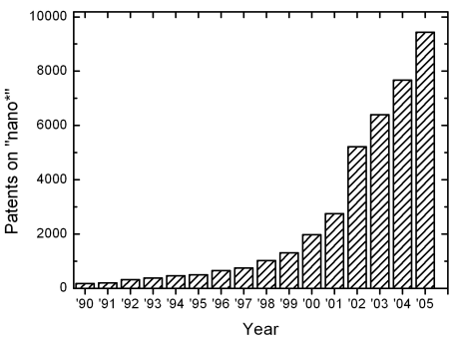
Figure 1: Number of patents on nanotechnology with time (Please use Insert caption for automatic numbering)

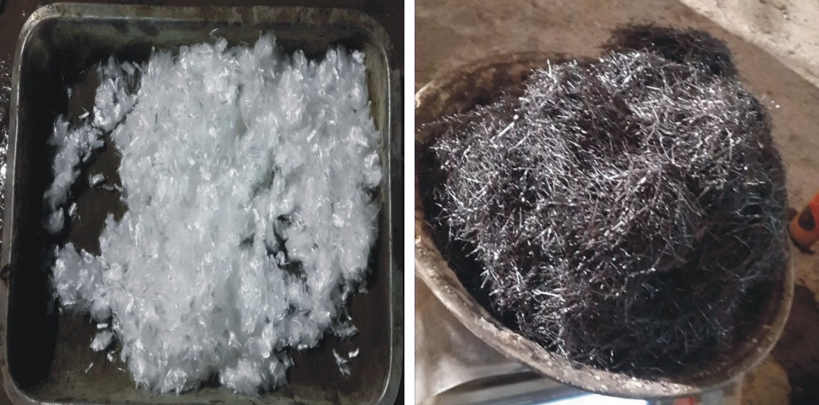
Figure 2: Images of Material/Equipment used

Equations
Each equation should be presented on a separate line from the text with a blank space above and below. Equations should be clear, written in equation editor, and expressions used should be explained in the text. The equations should be numbered consecutively at the outer right margin, as shown in Eqs. (1) - (2) below. Here is one example.
In this case, the governing system of equations can be written as follows:
(1)
(2)

Citation
Use the “Numbered Reference format” for references by using softwares (Endnote, Mendeley or Latex) that is, a numbered list at the end of the article, and formatted accordingly. [1]

SUBMITTING THE Paper
The full paper (not more than 6 pages) has to be submitted via submission tab on website:
https://web.uettaxila.edu.pk/icacee2024

Conference proceedings
The full-length manuscripts will be compiled into the conference proceedings that will be uploaded at conference website.

conclusionS
Conclusions should state concisely the most important propositions of the paper as well as the author’s views of the practical implications of the results.

ACKNOWLEDGEMENTS
A short acknowledgement section can be written between the conclusion and the references. Sponsorship and financial support acknowledgments should be included here. Acknowledging the contributions of other colleagues who are not included in the authorship of this paper is also added in this section. If no acknowledgement is necessary, this section should not appear in the paper.

REFERENCES

1. Ahmad, A. and A. Raza, Reliability analysis of strength models for CFRP-confined concrete cylinders. Composite Structures, 2020. 244: p. 112312.
2. Ganguly, S., A. Ahmed, and F. Wang, Optimised building energy and indoor microclimatic predictions using knowledge-based system identification in a historical art gallery. Neural Computing and Applications, 2020. 32(8): p. 3349-3366.
3. Ahmad, A., et al., Assessing The Load Carrying Capacity Of RC Members Through The Use Of Artificial Neural Networks, in HSTAM International Congress on Mechanics. 2016: Athens, Greece.

For further details, please visit the website: https://web.uettaxila.edu.pk/icacee2024
Email Address: icacee@uettaxila.edu.pk

